January 24, 2022

AIRTOMIC
75 Linville Way
Franklin IN 46131
(317) 738-0148

Dear Database Manager,
As a management official of AIRTOMIC, I hereby certify that:
AIRTOMIC will maintain and continue to follow their quality system as approved by the SAI Global:
- Only parts for which documentation is on file at this place of business, as described in AC OO56B, Appendix 1, will be sold for installation on civil aviation products.
- SAI Global has completed an audit and found our quality system to be incompliance with the provisions of AC 00-56B and AS9100D on 09/21/2021.
- A copy of the audit result is on file and available for inspection by any interested person.
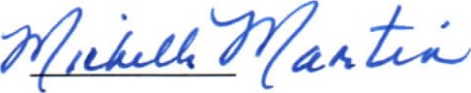 01/24/2022
Senior Manager's Signature Date

